ONLINE JOB PORTAL
SYSTEM

Description:

Online job portal system is a web-based application or project developed using ASP.NET. Here people seeking jobs can apply their resume or CV for different kinds of jobs, and employers can accept them. So, this portal focuses on management of data of companies or recruits looking for employees to fill their vacancies.
Job Portal System proposed as a project named “Jobmonster” focuses on mainly data storage. The various operations in data storage include the means to receive and analyze data, to extract, transform and load data, and to manage the overall data dictionary.

Online Job Portal System Project Abstract:
The proposed “Jobmonster” is a job portal website which is developed using ASP.NET 2008. C# has been used for server-side coding and SQL Server is used as the database of the system in which .NET Framework 3.5 is included.
Tools/Techniques Used:
- Software Used: Microsoft Visual Studio 2005, SQL Server & .NET Framework 2.0
- Development Platform: Microsoft Visual Studio 2008
- Front-end tool: ASP.NET
- Back-end tool: SQL Server
- Office Automation tools: MS-Word
A registration form including location of the company, kind of job, status of the job, qualification of the candidate, etc. is provided by the system. The data once entered in the system database is stored and can be modified or removed as required. When the stored data in the database becomes somewhat large, users can view data by scrolling.

Modules Overview:
The main modules involved in the job portal system are administrator, recruiter or employer module and jobseeker.

Administrator Module:

An administrator is provided to enter recruiter’s records such as type of jobs, description of candidates or jobseekers. Administrators will be provided a separate login. They are the ones who manage the entire job portal system. They are provided with their own system interface to access advanced features inaccessible to other users. Admins can view, edit and delete records. They can do any kind of alteration or modification in the database.

Employer module:

This module mainly deals with functionalities provided for the employers which include Employer registration, Posting of Job & Walk in detail. View profiles of job seekers and view the resumes of candidates applied for various jobs posted by them. The employer is having some tasks to perform without login and some tasks to perform after login. The employer module can display all the job details. Only the employer user can post the new job. The employer user can view all the details of jobseekers when he was entered into his login. This module contains all the walk-in details.

Job Street Module:

This module provides user interface to add the new jobs in job street. This module deals with the functionalities like Posting Jobs & Walk in detail. This module also includes job search functionality which is very helpful for job seekers to search various jobs. Also provides facility to filter the jobs based on various filters like Location, Experience and Functional Area. Keyword search is also available.

System Overview:
There are basically 4 sections in the system; the entire job portal project can be categorized into four sections as listed below.
- Recruiter section: It includes details of company (id, name, location, address, contact) which is to be entered by the user. Such data are stored or saved in the recruiter database.
- Requirement section: It stores various companies and job details in the form of job id, job title, job location, functional and technical skills, company and contact id, contact person and number, and many more other fields.
- Resource section: In this section, details of the candidates or jobseekers are stored. The data include their personal, technical and educational background or details, along with their previous work experience.
- Search section: Users can search for matching requirement and jobseekers as per their requirement.
Use Case Diagram:
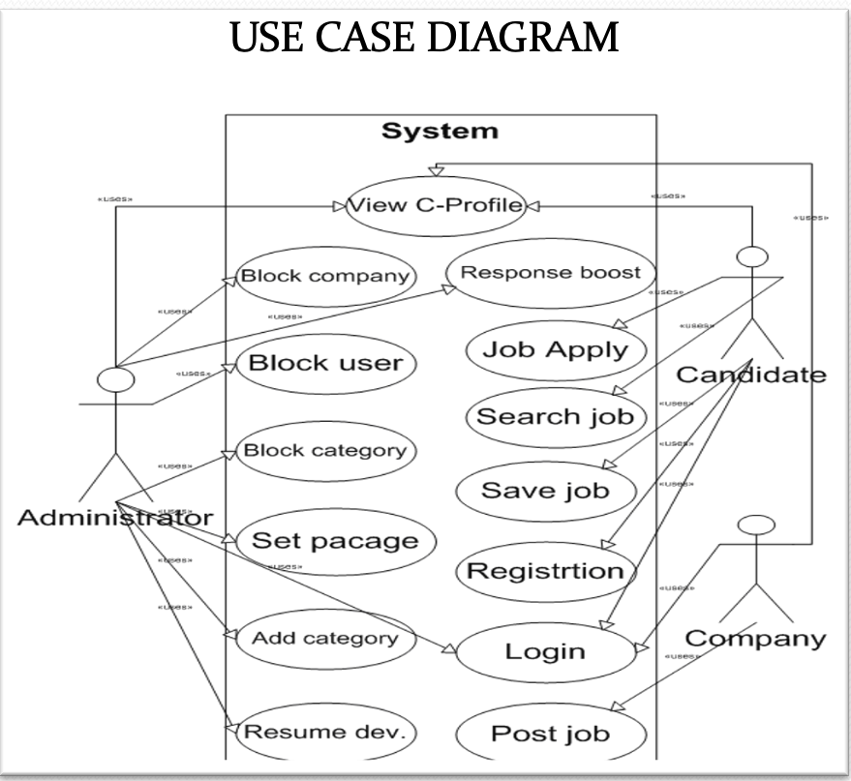

User Stories:

- As an Administrator I have to manage and backup the data of customers (jobseeker, HRs) , so that It can be restored on any disaster.

- As an Administrator I have to authorize access on request

- As an Administrator, I will have the highest level of access rights, so that I can cover areas such as database, security and integration.

- As an Administrator, I would be able to post and manage advertisements easily.

- As an Administrator I want to store the data entered by the user so that users can search for their matching requirements.

- As a Job seeker I have to search companies based on my requirements.

- As a Job seeker , I have to submit my Resume/Cv so that I can find a job as per my requirement.

- As a Job seeker, I need emergency customer support available when needed.

- As a Job seeker, I need a simplified dashboard to manage the advertisements and other facilities.

- As a HR Manager I want the access to see Job seekers profile and resume.

- As a HR Manager , I have to fill the registration form which contains the details about the vacancy so that the job seekers can apply accordingly.

- As a HR Manager , I need to view a candidate’s status so that I can manage their application process throughout the recruiting phases.

- As a HR manager, I need to get support for urgent recruitment.

- As a HR manager/recruiter, I want to surf the profile of the job seekers and collect information about them if needed.

Conceptual Diagram:

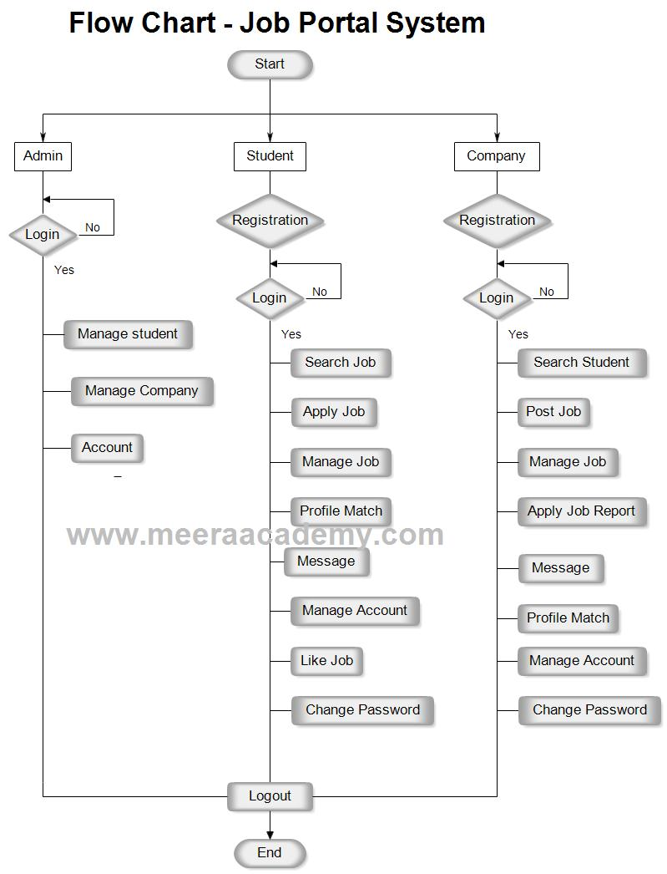

Database Design:

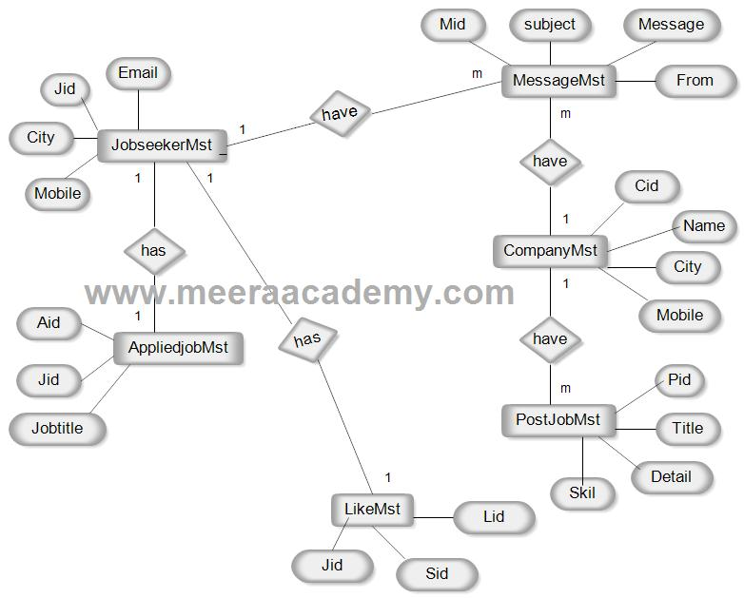

Class Diagram:

